GLOBAL COFFEE MARKET



Coffee continues to thrives as one of the most consume beverages globally.

* **Multiple factors drive the coffee market** such as ;
* **Demand of certified products** – Increasing emphasis on sustainability and ethical sourcing. Consumers are becoming more conscious of environment and social impact of coffee production. They seek out brands that – prioritize fair trade practices , promote sustainable farming methods , support the livelihoods of coffee farmers. This trend has led to the rise of certification life Rainforest Alliance and Fairtrade, which assure consumer that the coffee they purchase meets social environment standards.
* **Constant Innovation –** younger consumers switching from instant coffee to premium coffee due to quality .
* Caffeinated soluble on instant coffee to expresso.
* **Single – serve coffee brew system.**
* 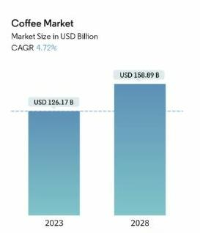**COFFEE MARKET SIZE IN USD BILLION ,**

Market size (2023) – USD 126.17 B

Market size (2028) – USD 158.89 B

CAGR (2023-2028) – 4.72 %

Fastest growing market– south America

Largest market – Europe

* **Coffee market is highly competitive and dominated by players** , Like
* Nestle
* JM Smucker company
* Kraft Heinz company
* Starbucks coffee company
* Private global brands such as ; Mossimo , Zanetti beverage group & Tchibo GMBH Focuses increasing their shares & global sales.
* Brazil being a largest producer of coffee , had the best year on records with an output of 67.9 million bag
* Italy sales coffee grocery sales increased by 23% in 2020 .
* Market affected by features such as , :
* **Product typ**e – whole bean , ground seeds , instant coffee , coffee pod and capsules.
* **Distribution** – On trade and Of trade (supermarket / hypermarket , convenience stores , retailer .
* **Geography** – North- America , Europe , Asia – pacific , South – America , middle east and Africa.

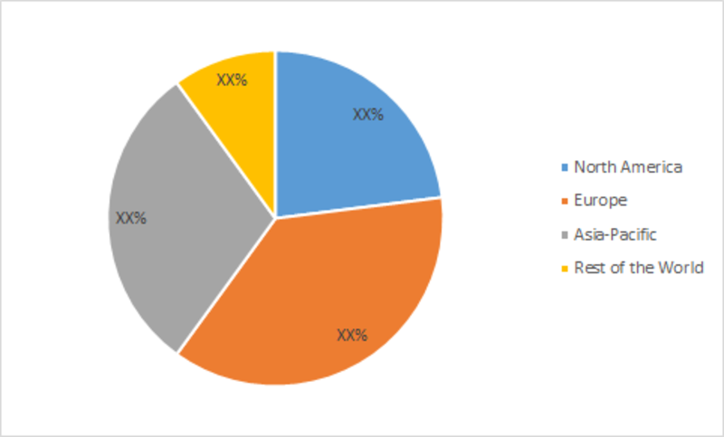

* **IMPACT OF COVID 19 -**

The onset of the novel Covid-19 has affected the coffee market as well. From daily consumption to exports, the pandemic has created a significant difference in numbers compared to the previous years. The report by World Coffee Portal showed that the U.S. branded café segment suffered a $11.5 billion sales decline in the past 12 months and is valued at $36 billion. Even though the production of coffee is estimated to rise by 0.5% to 169.6 million bags, world consumption is projected to remain 2% below the total production in the coffee year 2020/21. Moreover, coffee exports also fell by 5.3% in 2020.

* **OPPORTUNITIES FOR THE NEW ENTRANCES**
* Drive thru / pickup facilities
* Digital integration
* New trading formats

Example – Starbucks corporation , encouraging the customers to order through the app – record reached 22% of the transition in 2020.

It has been increased coffee sales of the largest coffee company on globally.